**If statement**

YouTube tutorial 10.

The code used in the video:

**import** java.util.Scanner;

**class** apples{

**public** **static** **void** main(String args[]){

**int** test = 6;

**if** (test == 9){

System.*out*.println("yes");

}**else**{

System.*out*.println("else");

}

}

}

Of course, the result is “else”.

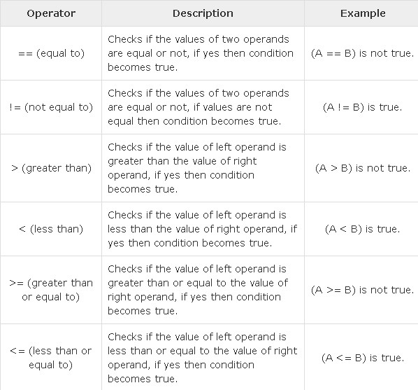

Also, we can write this:

**if** (test == 9 && test == 6)

The result : else.

